# Processing pipeline of EEG data for CAS task of the interoception project (FND lab)

Version 3.1, 30.08.2024

This manual proposed a pipeline using the matlab EEGpal (from Michael DePretto/Michaël Mouthon) scripts which call eeglab function for the processing. For the visualization and inverse solution, Cartool software will be used.

The abbreviation TF used in this document stands for Time Frame. This is the smallest unit of time in an EEG file, the length of which depends on the sampling frequency. For example, if the sampling frequency is 2048 Hz, then 1 TF=1/2048= 0.000488s = 0.488 ms.

If you need to know the parameters you used in a previous in a previous processing, look at the PIF_*.txt file in the output folder of each step.

NOTE: the files following the preprocessing steps now should be named accordingly “Interoception_CAS_PXXX_ddmmyyyy_condition#_filtered_exported_ICApruned

* Filtered; when filtering was done
* Exported: when exporting it from sef (Cartool: visual inspection for bad electordes) to set for ICA
* ICA pruned: when ICA was completed and eye components were removed

NOTE: if there is only ONE condition of a participant it will be excluded, if there will be one round per condition it will be included and be balanced (but have more variance9, if there will be two rounds or one but only one of the other condition, e.g. 3 rounds per participants we will also include all three, as for the analysis at group-level the imbalanced variances across condition will not be a problem anymore

# Open EEGpal toolbox

Before to start, I advise you to copy the folder of EEGpal toolbox on your hard drive and to add this path (‘Add folder’ option) in your Matlab. You have to due it only the first time, then it will be saved:

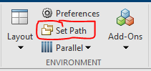

Now to open EEGpal, use the following command line in Matlab :

>> EEGpal

# IMPORT DATA

Create a folder with all the files that you want to process (as the chosen folder will be considered with all its  
subfolders) and name them with the Pcodes e.g P001-P030 / P050, P061, P077-P090

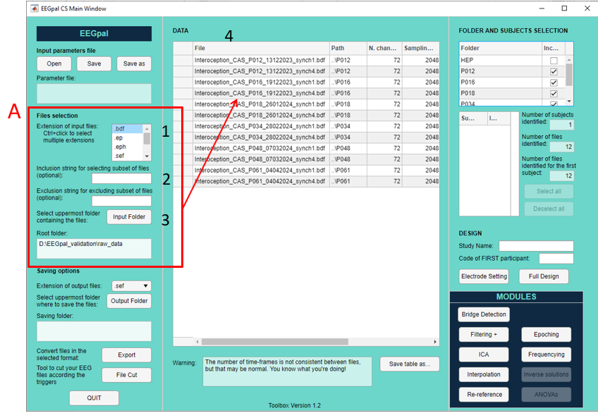

1. Select the raw data format. In our case, leave as '.bdf'.

2. optional: If you want to filter a part of the files, you can write in a character string that is common to the files you want to select (for example, in our case, if you write 'normal', then the toolbox will select only the files with the word normal in their name).

3. Press the Input Folder button and select the directory containing all the EEG files you wish to import. These files can be placed in sub-directories. The toolbox will select all files corresponding to the search criteria defined in 1 and 2, whether they are in the main folder or in sub-folders. It takes some time to fill the list in the central panel. Give Matlab time to complete this list before doing anything.

🡪 if we want to exclude an entire subfolder (for example exclude Pilots) at the right upper corner, you can deselect a subfolder

4. The main panel lists all the files that the toolbox has found. It informs us in order: file name, location on disk, sampling frequency, total number of electrodes recorded in the file, and the number of TFs contained in the file.

If you have several files per participant (which is the case in CAS experiment), you can specify in the toolbox to group them together (which will be necessary for ICA):  
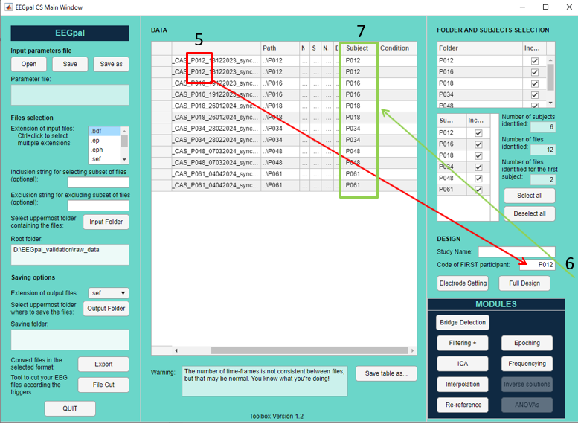

5. Include the participant's code in the EEG file names. Identify the code for the first participant in this list.

6. Enter the code for the first participant (determined in point 5).

7. The toolbox will then automatically identify which participant the files belong to. The participant codes are added to the "Subject" column. Check that the values are correct.

# Loading the electrode coordinate file

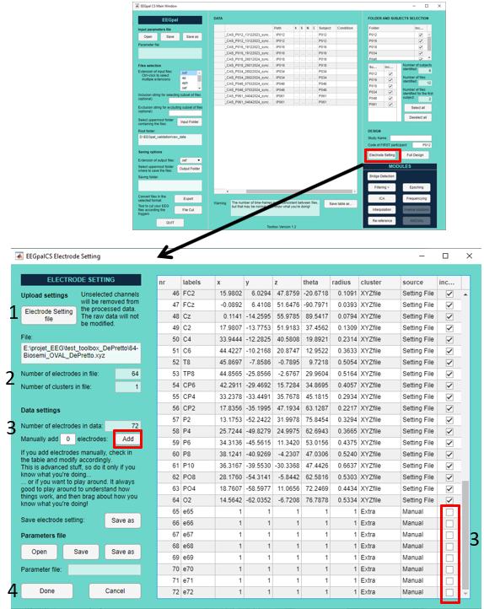

1. Load the .xyz, .els or .locs file containing the spatial coordinates for locating the electrodes on the EEG cup.

In our case, you'll need to load the *biosemi64_officialAB_update.locs* file (located at the default proposed position) for preprocessing.

2. The toolbox informs you of the number of electrodes present in this coordinate file, as well as the number of clusters. A cluster is a group of electrodes that can be specified within an .els file (e.g. to separate EEG electrodes from external channels). **You don’t need to consider this point for interoception study.**

3. The toolbox compares with the number of electrodes in the EEG files.

In our case, the EEG files contain 8 more electrodes than the coordinate file (ECG channels). Click on the Add button to manually add these 8 channels to the table on the right. Make sure that these new electrodes are deselected (the default setting) so that they are ignored/deleted (and not interpolated) in the analysis.

4. Click on Done

By doing that, it will automatically remove the ECG channel for the next steps.

# Bridge Detection

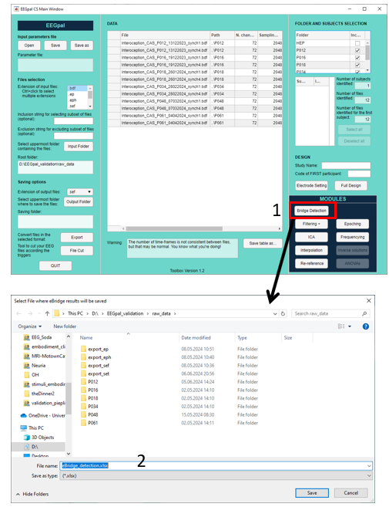

1. Press on the “Bridge Detection” button.
2. Select the location of the .xlsx output file

This module calls the eeglab script eBridge which automatically detect if two or more channels are bridged (same signal). Open the .xlsx output file to check if there is any. We will need this info for the ICA and interpolation step.

Time estimation ~= 2 minutes per participant

3.Check the excel file on the C column (percentage of channels that are bridged; if 0 = good to go, no bridge detected, if there is a number we have to delete one of the bridged chanells)

# Filtering

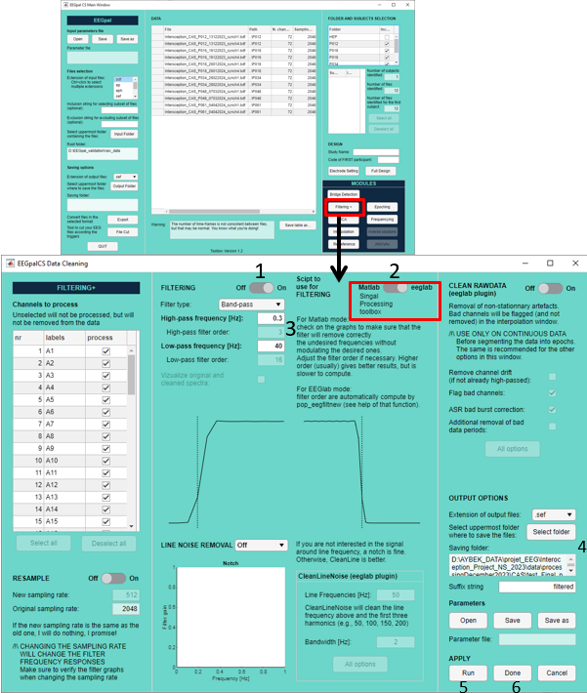

1. Activate the Filtering
2. Activate eeglab option (to call the eeglab filtering function [pop_eegfiltnew]with automatic filter order [which will be the same across participant if the sampling rate is keep at 2048Hz]))
3. Specify the cut-off frequency of the filtering High -pass = 0.3 and low-pass: 40Hz
4. Keep the data output file as .set (as we need this for the Cartool visualization afterwards)
5. Create a '01_filtered' folder. Select this output folder, where the results will be saved
6. To execute the processing click on **Run**
7. Then the processing if finished, click on **Done**

Note: Supplementary Notch Filter at 50Hz or CleanLine are NOT required because the low pass filter has already a very sharp cutoff frequency.

Time estimation ~= 4 minutes per participant

# Visual inspection of the data (CARTOOL)

For the next step (ICA decomposition), we need to know if there is any bad channel in the data like technical artefact, etc… Open the filtered files (generated at the previous step) in Cartool and look for bad channels.

Click on the filtered files and open in Cartool.

Look at the channels visually. Hereby only note the CLEARLY bad channels, as the pot. Problematic files can also be taken care of with averaging or then interpolation. Note that it is still important to visually detect and thus exclude from ICA those channels who are clearly bad (as otherwise the ICA can not perform a nice factor decomposition and would for example split an eye factor into 5 different factors)

Example of bad channels:

* 1. Electrodes with continuous oscillation different from neighbours

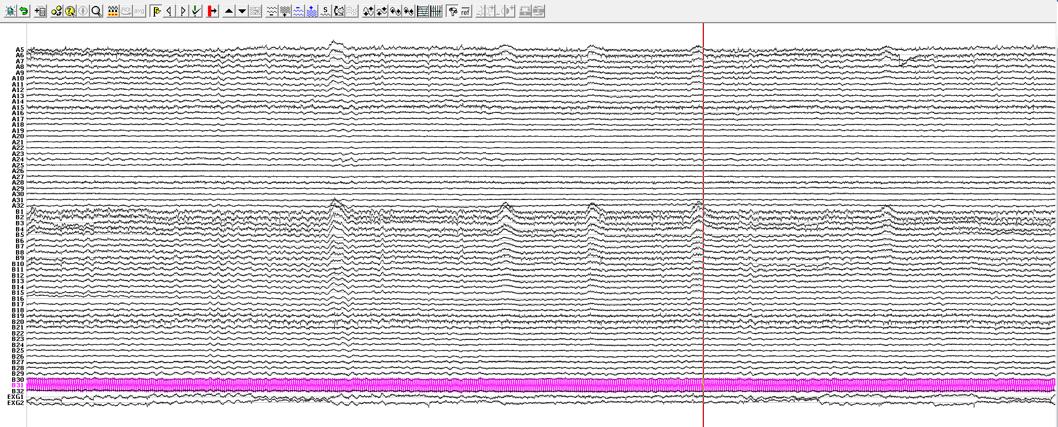

* 1. Regular spike  
     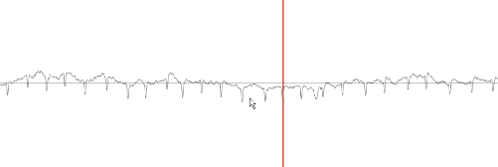
  2. A single channel with abnormal high amplitude different from neighbours during a long time period  
     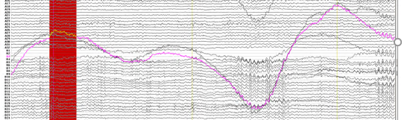

Look only at technical artefact and not to transitory movement of the participant. If you notice such channels, note it!

🡪 For CAS; look at first and last file for bad channel-detection and write down all bad channels in a file, to later interpolate (and in the next step exclude from the ICA analysis)

# ICA

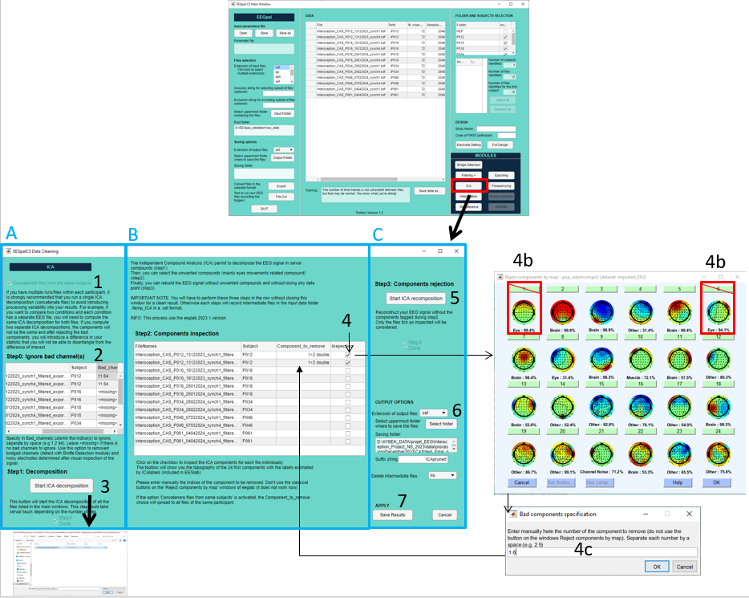

The Independent Compound Analysis (ICA) permit to decompose the EEG signal in serval compounds (panel A). Then, you can select the unwanted compounds (mainly eyes movements related compound) (panel B). Finally, you can rebuild the EEG signal without unwanted compounds and without losing any data points or electrodes (panelC).

IMPORTANT NOTE: You will have to perform these three steps in the row without closing this window for a clean result. Otherwise each steps will record intermediate files in the folder *.\temp_ICA* in a .set format. If you want to redo step B and C without redoing step A (very long), load in the main windows the files saved in *.\temp_ICA\decomposed* and then open the ICA module which will automatically detect that the decomposition is already done.

**StepA**

1. Select the option “concatenate files from the same subjects” when you have several run/files within each participant. It is strongly recommended to do a single ICA decomposition (concatenate files) to avoid introducing processing variability in your results. For example, you want to compare two conditions and each condition has a separate EEG file, you must compute the same ICA decomposition for the two files. If you compute two separate ICA decomposition, the components will be not the same and after the rejection of bad components, you will introduce a difference in your stat that you will not able de disentangle from the difference of interest.
2. In this table, enter the indices of all the bridge channels (determined in step 3 of this manual; if for example A5 and A6 form a bridge, we will exclude both these channels and later interpolate them with their neighbours) and of bad channels (determined in step 5 of this manual; here only use those who were clearly bad, and keep the “probably bad” included, as we can at a later step still decide to interpolate them). Warning: don’t put the electrode name (for example A11 B32) but the numerical indices of channels (11 64), indicating the 11th and the 64th channel. If you have a doubt about number to enter, look at the header line of the *eBridge_detection.xlsx* output from step 3. If several channels, separate them by a space.  
   If no channels have to be ignored, leave as it is “<missing>” or leave it empty
3. Start the ICA decomposition of your EEG files (take a long time). The intermediate results will be recorded in the folder .\ICAtemp\decomposed\*_ICAdecomposed.set.
4. Please select the *biosemi64_officialAB_update.locs* file in the browse window when it is asked to do so.

Time estimation ~= 60 minutes per participant

**StepB**

Note: The path of the input files in the central table are automatically updated after the execution of stepA. In the case of crash or if you need to reprocess your files afterwards, you don’t need to recompute the ICA decomposition (stepA). You can import the ..\ICAtemp\decomposed\*_ICAdecomposed.set generated by step A in the main EEGpal windows (section Import Data and Loading the electrode coordinate file step of this manual) and directly perform this stepB.

1. Click on the checkbox to inspect the ICA components for each file individually.
   1. The toolbox will show you the topography of the 24 first components with the labels estimated by ICAlabels (included in EEGlab).
   2. In the current example the compound 1 (blink = vertical movement) and the compound 6 (horizontal movement) are clearly associate with eye movement.
   3. Please enter manually the indices of the component to be removed, separated by a space (‘1 6’ in this example). The specify value will be added in the coloumn *Components_to_remove* of the central table. If the option 'Concatenare files from same subjects' is activated’ (point 1), the components to be removed and the inspection tick will spread to all files of the same participant.
   4. BE AWARE: you have to click all the files (as for the further steps only the ticked files will be included), even if you don’t choose any factor to decompose in the ICA

**StepC**

1. When all the files of the central table are inspected (tick), press on the button *Start ICA recomposition* Reconstruct your EEG signal without the components tagged during stepB. The intermediate results will be recorded in the folder ..\ICAtemp\recomposed\*_ICArecomposed.set
2. Now, we are going to export these results in the format you want. Create a 'ICA' folder. Select it as output folder
3. Press on *Save Results* to perform the export of the final result with the option you have chosen in previous step. It will automatically update the table of the main EEGpal window and close the ICA module + write a log file with the different option you have selected.

Time estimation ~= 30 s per participant

# Interpolation (CARTOOL)

This will done in three separate steps.

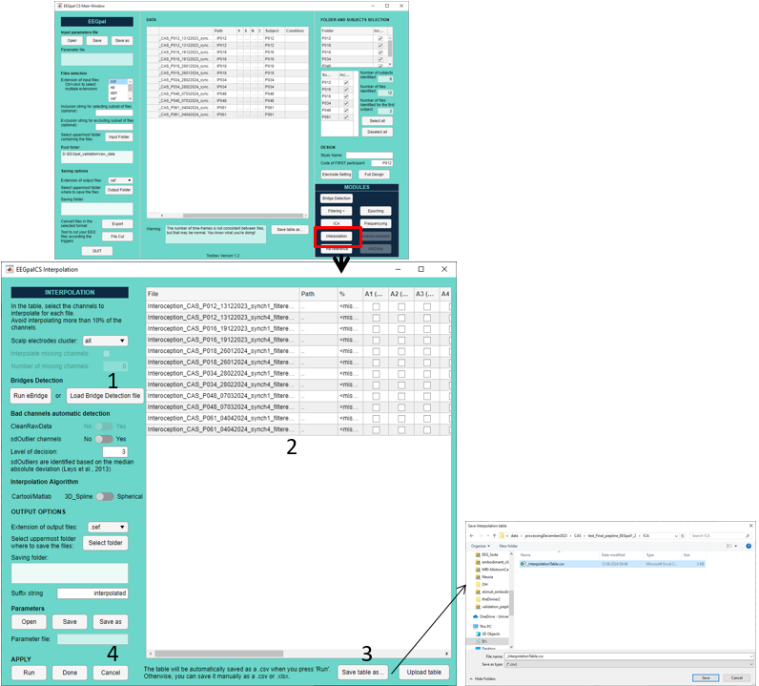

**Step A: Save the interpolation table in**

1. Open the Interpolation module
2. Click on the button “Load Bridge Detection file” and select the *.xlsx file created in step 3 of this manual (Bridge Detection)
3. This table permit to indicate which channels has to be interpolated. The third column compute the % of rejected channel. This value must be keep under 10%. It is easier to save the table in txt and to work in Excel software (4).
4. Press on the “Save Table as” to save the table on you hard drive
5. Open the file with Excel. Use the tool “Data->Text To colums -> Delimited by comma” to format the file in columns.   
   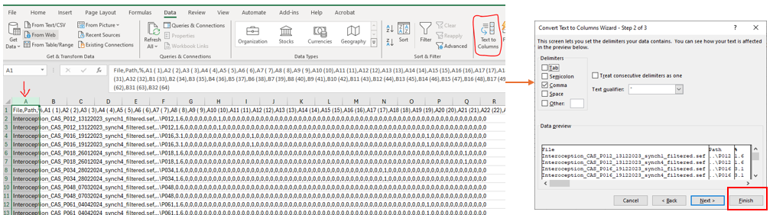
6. This file will be your decision file about the channels to interpolate. Leave 0 to keep a channel and put 1 when you want to interpolate it. If you want to have an automatic calculation of the % of channel rejection, insert the following formula in cell C2: =(SUM(D2:BO2)/COUNT(D2:BO2))*100 and then copy/past it in all cell of the third column (column C).

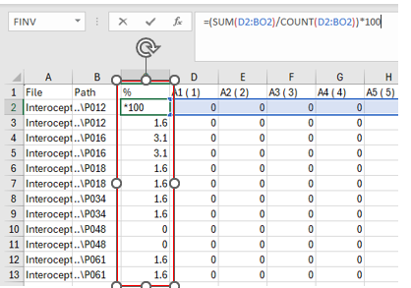

Remember that you can interpolation maximum 10% of signal (so 6 electrodes for a 64 EEG cap)

1. Add the **Bad channels** determined in step 5 of this manual in the table (put value “1” to interpolate the corresponding channel).
2. Save As the file into *.xlsx format to work in it (referred as *interpolation file* in the next section).

**Step B: Determine/chose the channels to interpolate**

In order to make the visual inspection to detect bad electrodes, we are going to make a first temporary ERP analysis. Create a temp folder on your drive.

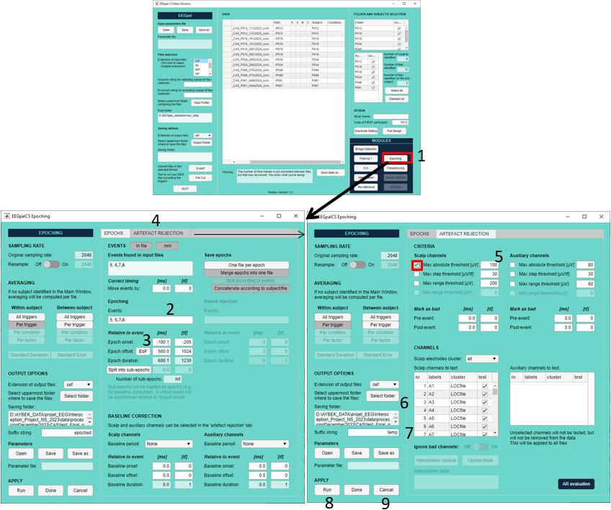

1. Open the Epoching module
2. In Events section, put 5, 7 as arguments (as we are only interested to look at these two markes; sound in syn and sound in asynch for the sake of looking at channels)
3. For the Epoch length, specify -100.1 ms for onset and 500 ms for offset
4. Click on the panel “Artefact Rejection” tab
5. Activate the rejection criteria Max absolute threshold = 100 (arbitrary argument which should mirror “movement” of the paticipants)
6. Select the destination *temp* folder you have created
7. Change the suffix string for “temp”
8. Press on run
9. When it is finished, press on Cancel

As results, you get:

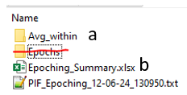

* 1. Avg_within :contains the ERPs
  2. Epoching_Summary.xlsx : summary to see how many Epochs has been discarded

Now you will inspect the ERP to detect potential bad channels after averaging. Inspect two files per participants **(one file trigger 5 and one file trigger 7).**

1. Open Cartool
2. Create a link any file (.lm) and drap_and_drop the electrode file 64-Biosemi_Oval_DePretto.xyz and “save as ..” it in a place easy to access.   
   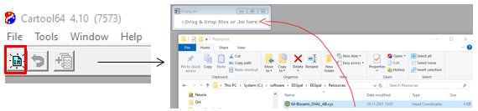
3. Visualisation:
   1. Drap and drop an ERP file into the lm file  
      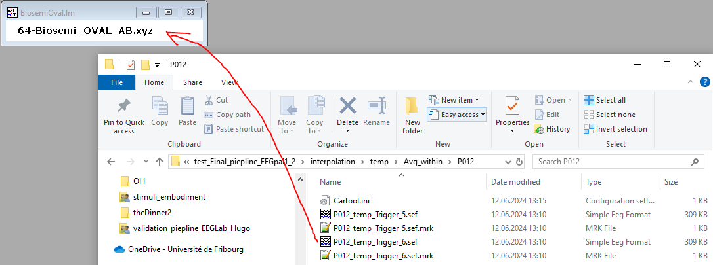
   2. Press on the topography windows, then 1x ,then 1x, then 1x
   3. Press on the electrode windows, then 2x
4. **Test visually** **the topography**
   1. Put the cursor at the origin
   2. Move the cursor with the keyboard right arrow and look carefully at the change of topography. You are looking if the electric charge of an electrode is incoherent with the neighbor electrodes during a stable period of time (and not at the ERP end). For example (see the picture below), the electrode highlight by the red rectangle has an abnormal polarity stable in time = electrode to interpolate  
      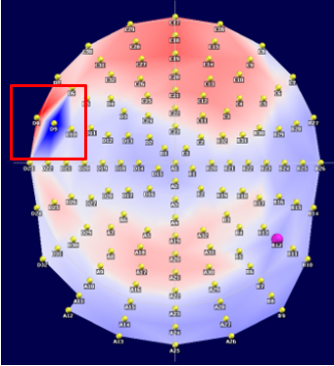
5. **test visually on the eeg-track**
   1. Click on the electrode window
   2. With the keyboard, press *on “SHIFT” + “-“* keys, then press 5x on *“+”* to see only 5 electrodes on the screen
   3. With the keyboard, press on *“CTRL” + “↑”* key to increase the amplitude (make the comparison easier)
   4. Change the channels on the screen with *“↑”* and *“↓”* key. Carefully look the trace of electrodes. If there is a weird electrode in comparison to **SPATIAL** neighbors (huge difference of oscillations) = electrode to interpolate.   
       For example (see the picture below), B12 is odd comparing to its direct special neighbors.
   5. 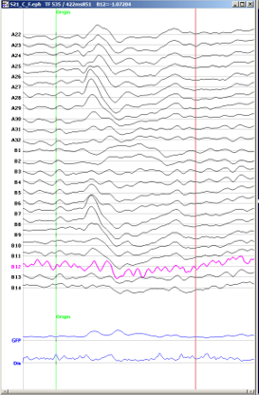

NOTE: these steps should ideally be done in parallel for marker 5 and marker 7 per participant, to also see how the channels change over the conditions (IF ONLY ONE CONDITION has “suspicious” channels and the other not, keep the channel and don’t interpolate as it might be innate to the condition) 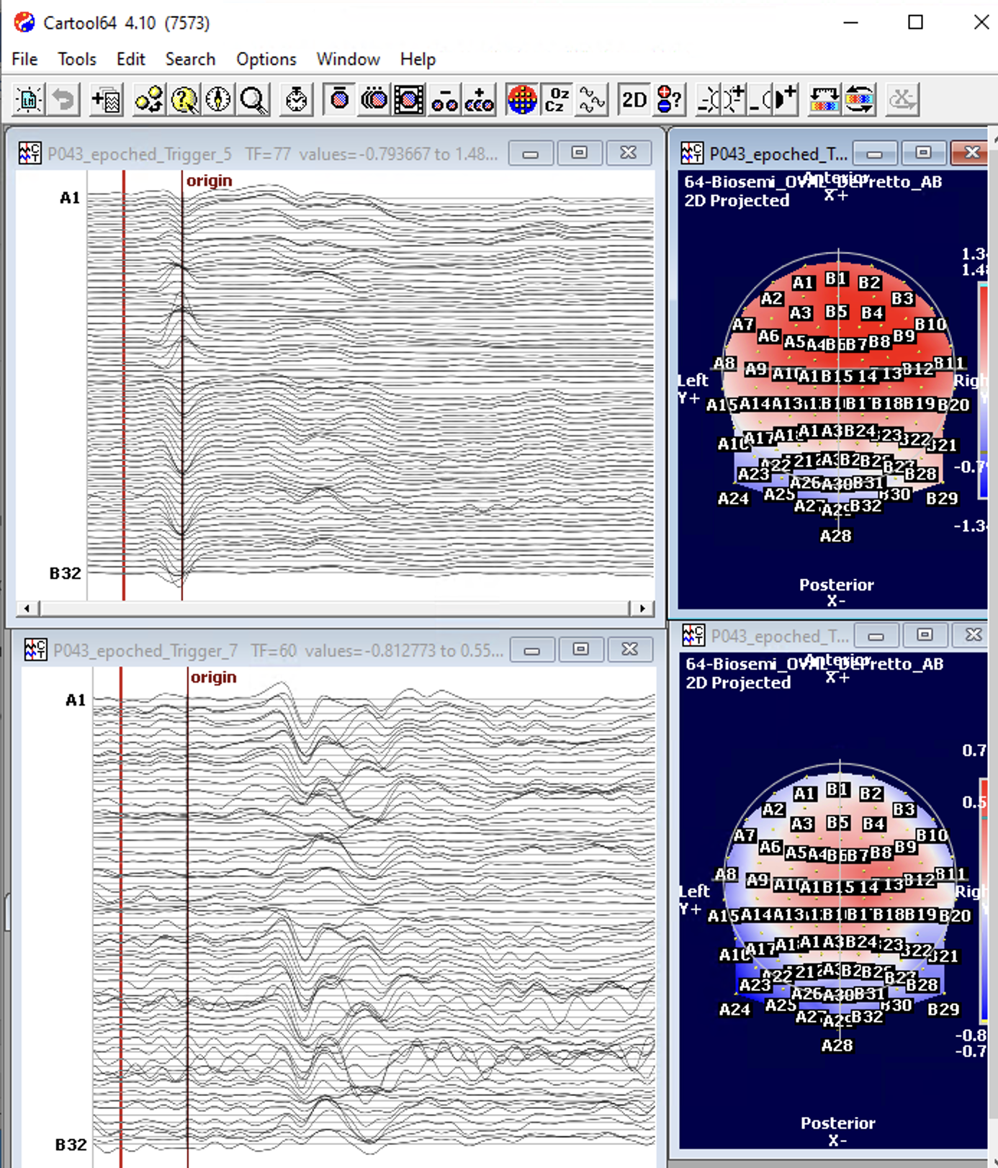

Further tools to help decide whether a chanell needs to be interpolated or not:

* Select the channel you are insecure about with the middle button of the mouse and go to Selection > Keep current selection

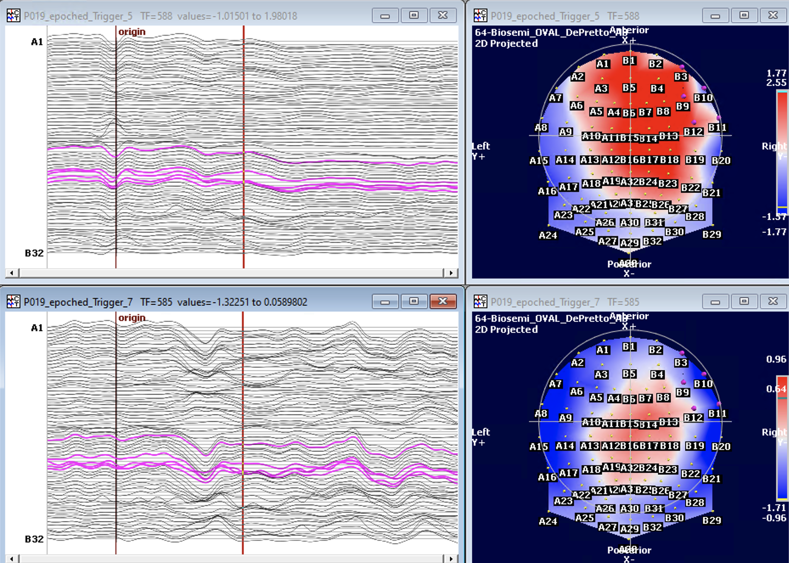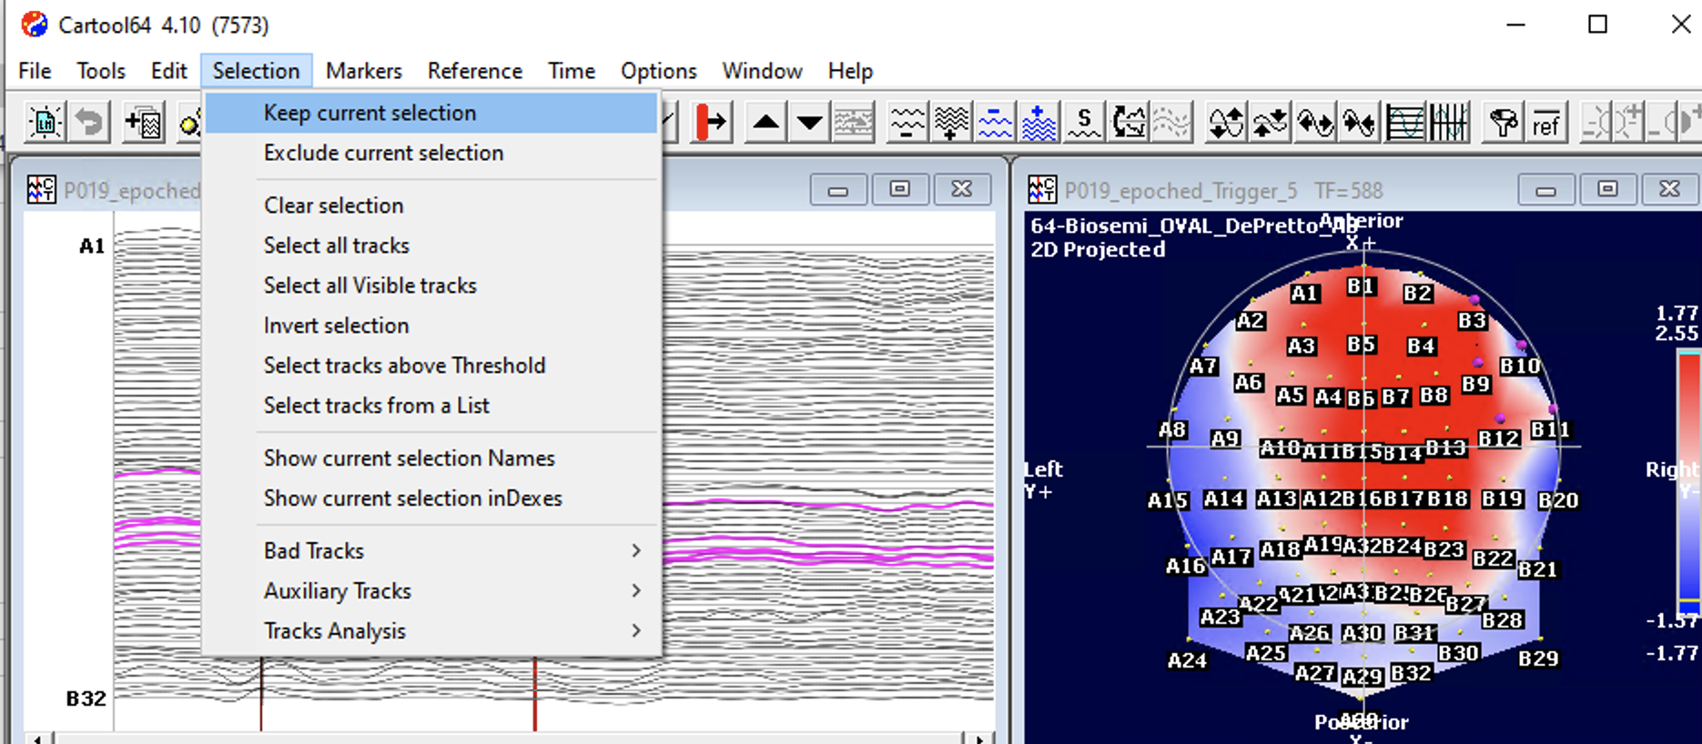

* Only the selected ones are presented and you can see the channel within its neighbours instead of only within the numerical order. Then press the “S” on the keyboard to stack the channels, to look at potential effects of higher amplitude/threshold changes

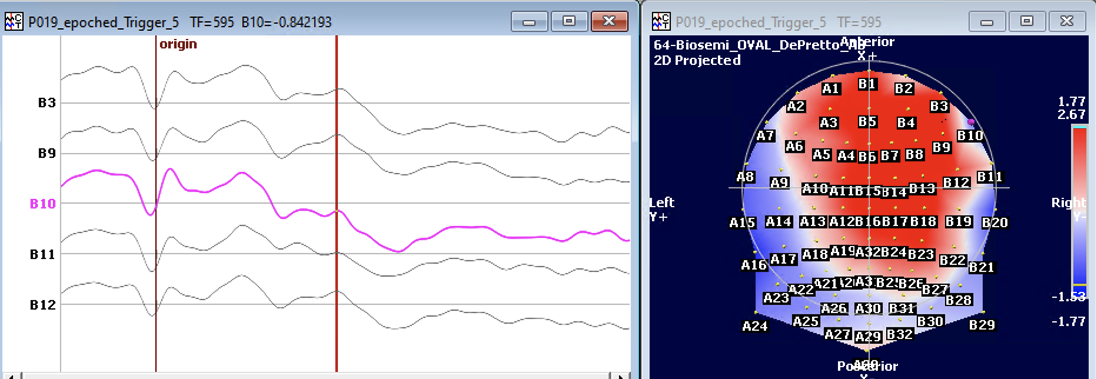 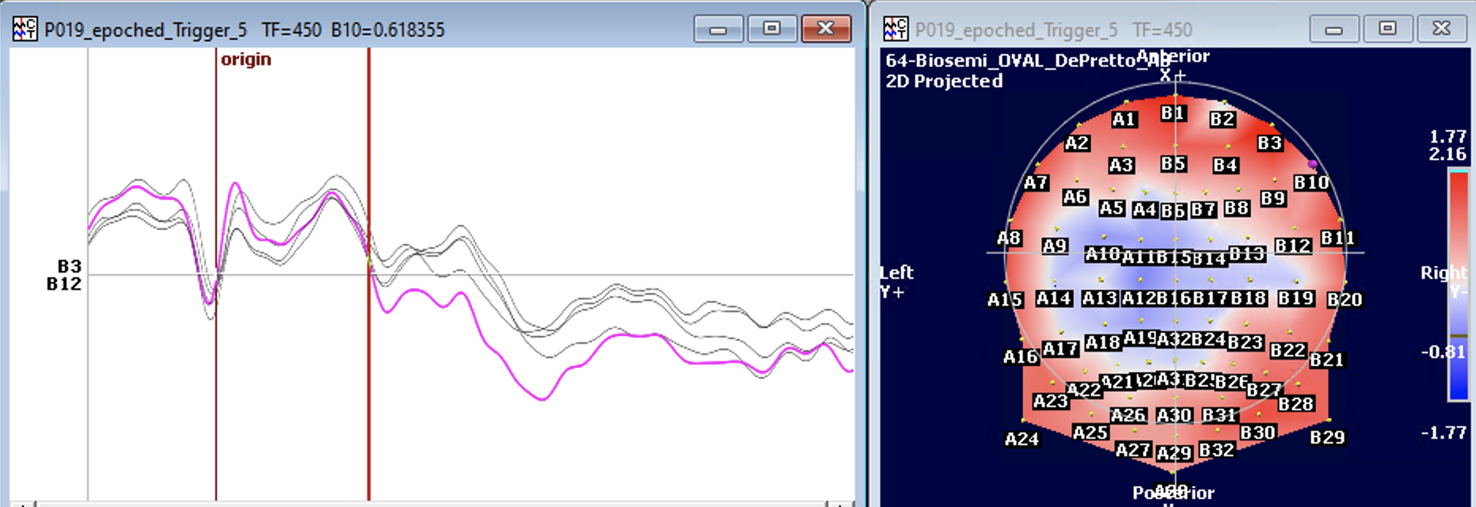

ALSO: ideally have it checked by another person, for inter-rater reliability!

1. Close the .lm file and reopen the .lm you saved in step b. Repeat this steps **c** to **e** with the ERP file [trigger 7] of the same participant.  
   Take the decision about which electrode you detected you will actually interpolate and fill the interpolation file according to your choice. Do forget the following rules for your decision:
   1. Max 6-7 electrodes per participant to interpolate (10%). If you really need to have more, consider the participant as an outlier.
   2. interpolate the SAME channels across one participant (same channels need to be interpolated across the 4 CAS files)
   3. Bad channels detect in step 5 has the priority.
   4. Then bridged channel detect in step 3 has the next priority.
   5. Then the possible noisy electrodes you have notice in point d (topography) and f (electrode trace). If two neighbors are bad, interpolate only one of them (preference to the electrode which is not on the border of the hat).
2. Fill the interpolation file with your choices and saved it (keep the .xlsx format)

**Step C: Apply interpolation**

If you have close the EEGpal windows, you have to reimport data CAS *.ICApruned.sef in the memory (see step 1. IMPORT). Don’t forget that to change the file type of **import as .sef** instead of .bdf. You also need to import again the coordinate file (as in section 2 Loading the electrode coordinate file). This time, the eeg files has 64 channels and not 72. So, you don’t need to add 8 supplementary channel. Don’t forget to specify again the participant code in the right column (as explained in step1).

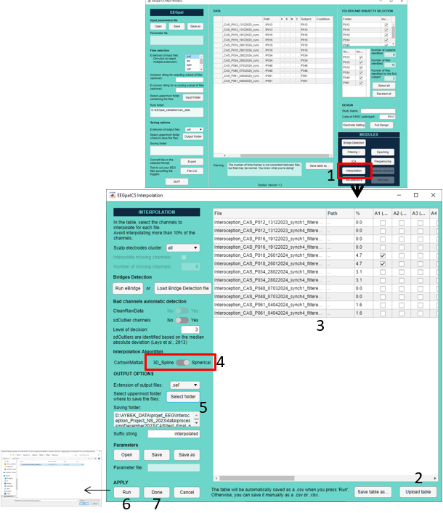

1. Open the interpolation module
2. Press on the button “Upload table” and select the *interpolation file* *.xlsx you have saved in previous step to import the interpolation table
3. The interpolation table should be filled with the value you enter in the interpolation file (.xlsx). Check if everything is ok.
4. Select the Spherical interpolation method (official script from eeglab)
5. Create a 'interpolated' folder. Choose it as folder of destination for the output files.
6. Press on the button run. A window will ask you to select the coordinate file. Please select the file biosemi64_officialAB_update.locs
7. When the processing is finished, press on Done

Time estimation ~= 10 s per participant

# Reref

The final step in pre-processing is to change the reference. This is particularly necessary for a Biosemi system. Our convention is always to consider the average reference.

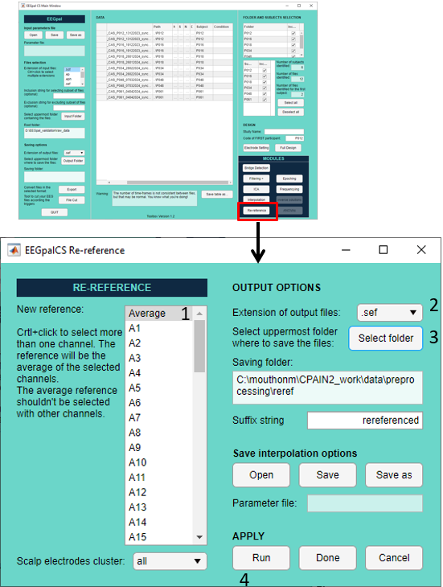

1. Leave Average as default to use the average as reference
2. Select parameters for pre-processed file saving format. Select .sef format
3. Create a 'reref' directory in the preprocessing folder and select it as the destination directory.
4. Press the Run button to apply.

Time estimation ~= 10 s per participant

# Epoching/Averaging

This step permit to create the final evoked related potential (ERPs) which will be used for statistical analysis (separate manual will be provided).

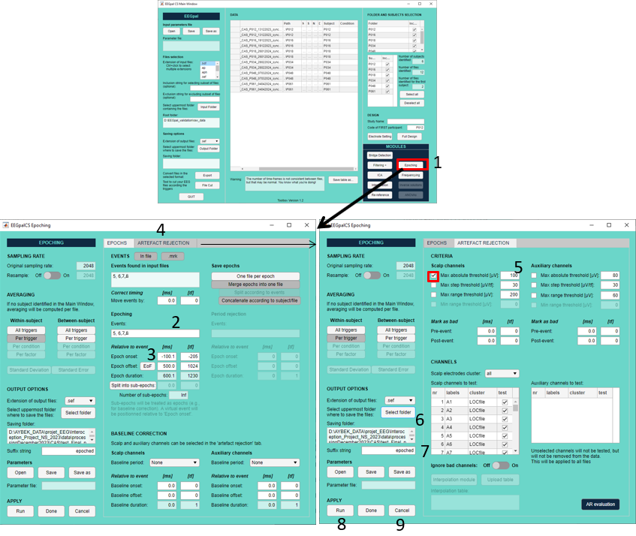

1. Open the Epoching module
2. In Events section, put 5,6,7,8 as arguments (to look at all the events)
3. For the Epoch length, specify -100.1 ms for onset and 500 ms for offset
4. Click on the panel “Artefact Rejection” tab
5. Activate the rejection criteria Max absolute threshold = 100 (for movement)
6. Create a folder “epoched” and select it as the destination folder

Change the output files to .ep (so that we can import it into Ragu afterwards)

1. Check that the suffix string is “epoched”
2. Press on run
3. When it is finished, press on Cancel

Time estimation ~= 30 s per participant

# Compute de Missmatch Negativity (optional)

To compute the MMN, we need to make the following substraction: Sound-noSound (trigger 5-trigger 6 for synch and tigger 7 – trigger 8 for asynch).

1. Open Cartool Software
2. 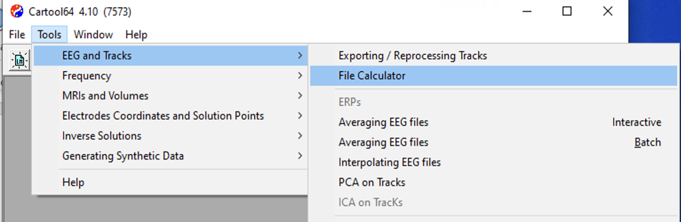
3. Toosl > EEG and Tracks > File Calculator > drag the two ERP files generated at previous step .\epochs\Avg_within (trigger 5 and trigger 6) into the field : in the expression we write Group1-Group2 (to have the difference between sound-nosound)
4. Choose an output directory the folder 07_MMN and use .ep as output format.
5. Press on Process

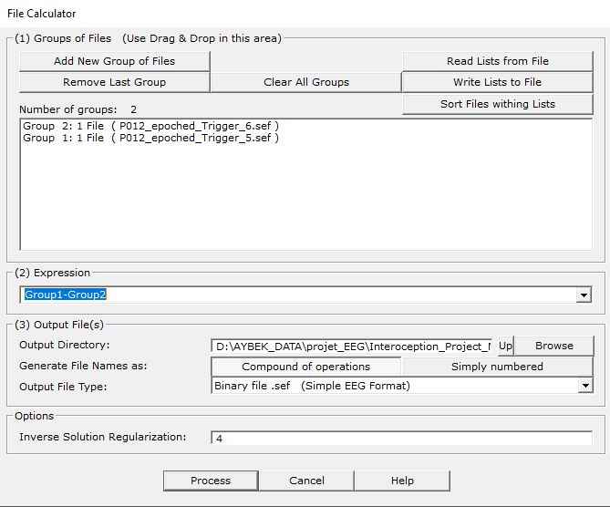

1. Repeat step 2-4 for the condition ASYNC (7=sound and 8=mismatch)

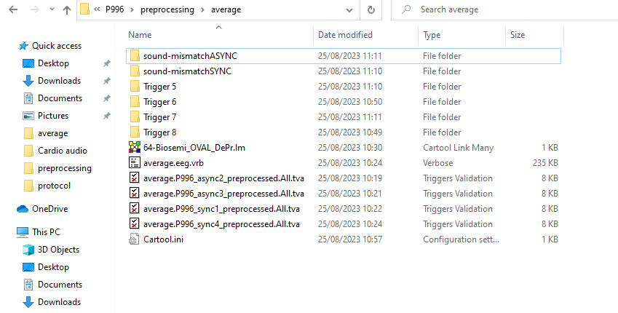

* + - Calculate the MMN in batches:
      1. copy all epoched files from the 06_epoched > Avg_within   
         into the folder 07_MMN and then select all the same conditions

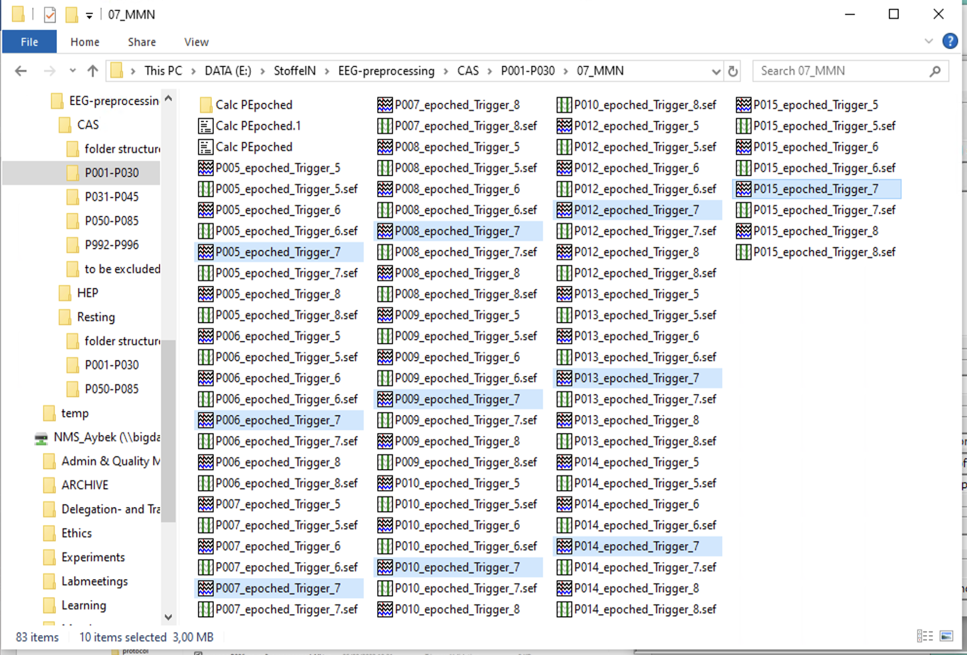

* + - 1. draw them into the File calculator and do the same with the other conditions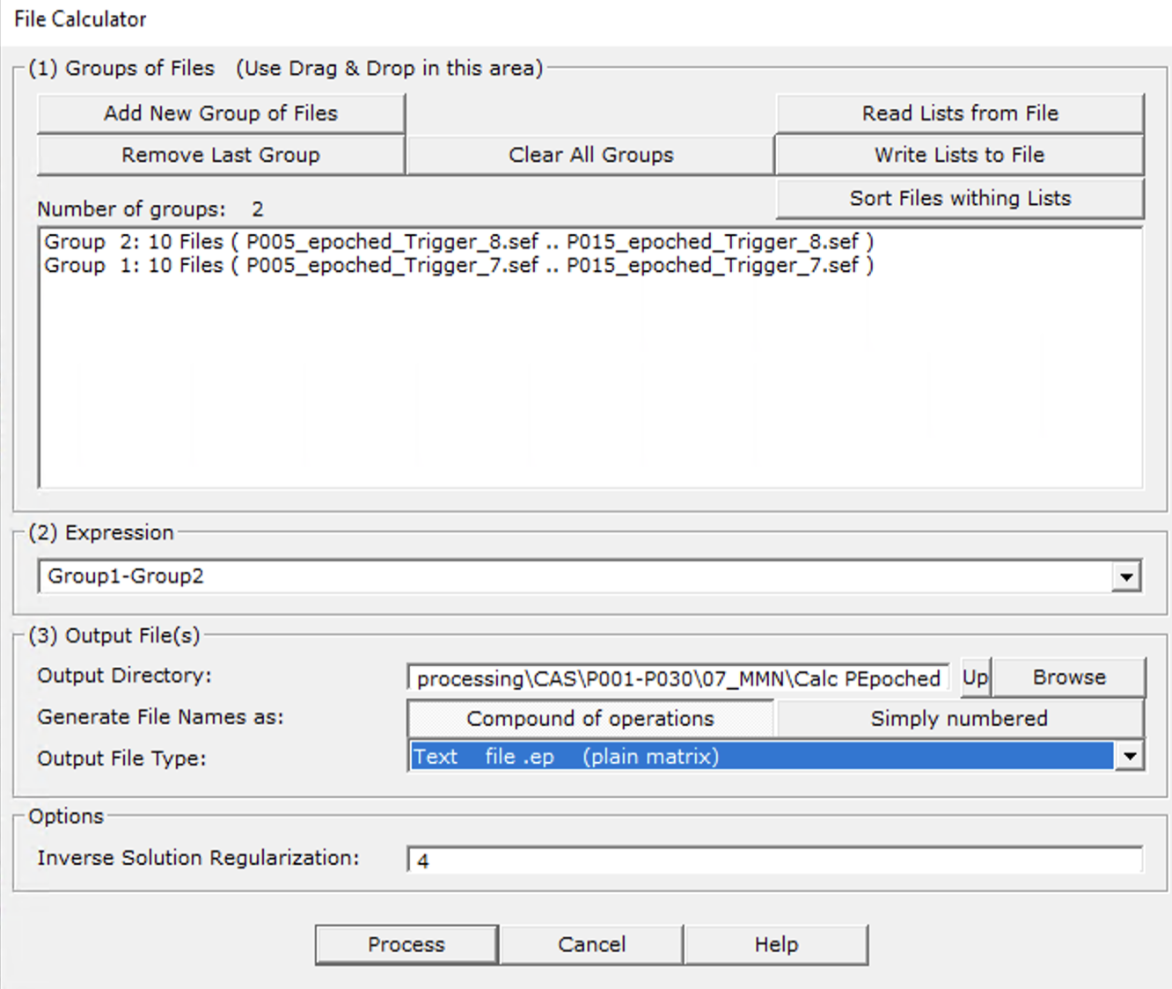
      2. calculate them all in one step
      3. delete the copied files to save storage space

# Annexe

***Epoching:***

If I want to see how much of the files was kept for creating an averaged epoch, and how much was discarded (due to bad epoch) I can look at excel file “Epoching Summary” stored in epochs

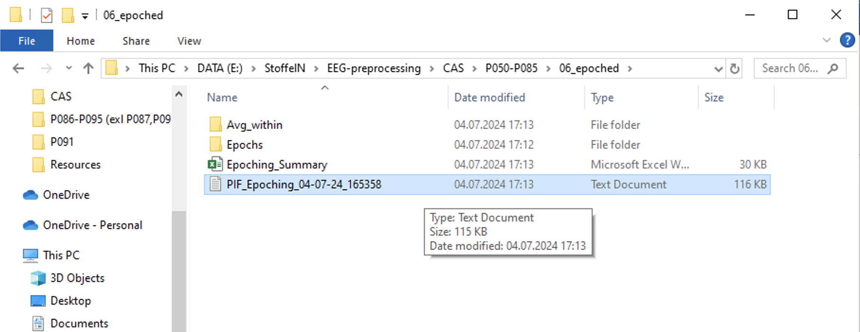

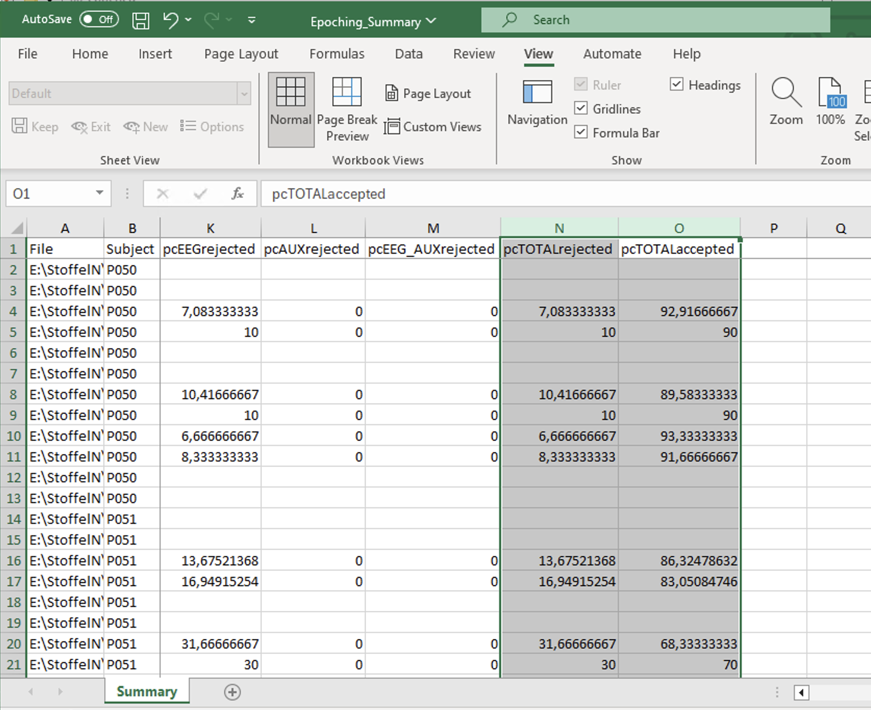

For example:for P050 between 89.68-93.33 % of the files could be kept, while 6.66-10.42% had to be rejected.  
NOTE: at least 2/3 of a participant must be kept (thus cut off is 67 % of good epochs)

***ICA decomp:***

If I want to re-look at decomposed factors from the ICA

* Open eeglab in Matlab
* Load existing dataset

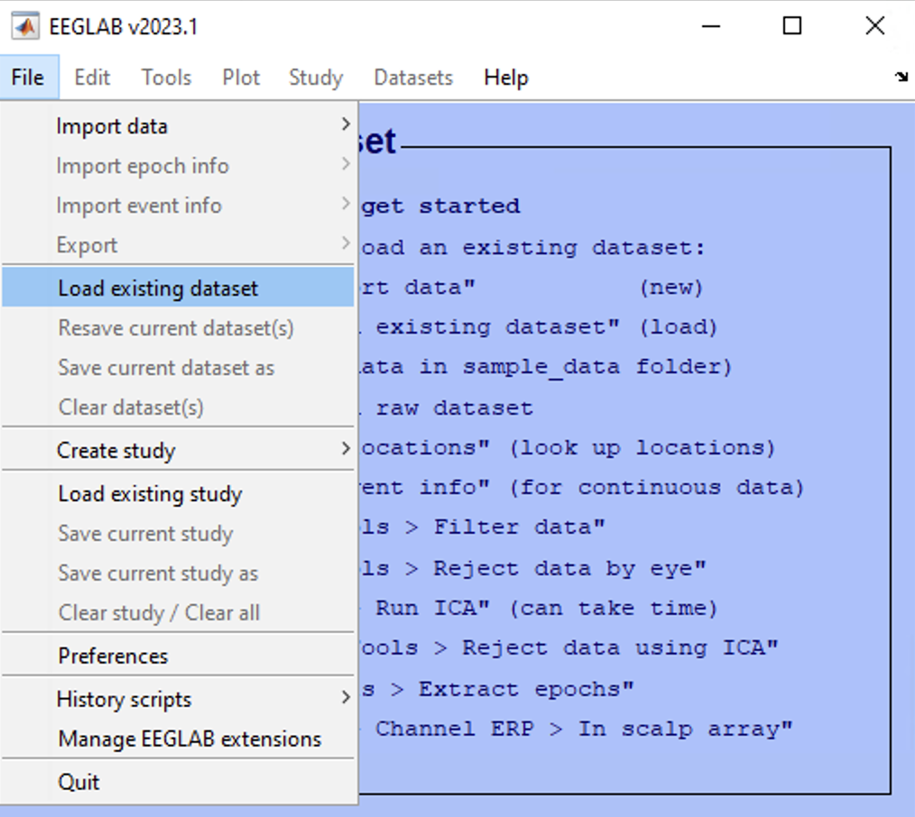

* Choose the set file stored in the root folder for the ICA (filtered) in the folder ICAtemp > decomposed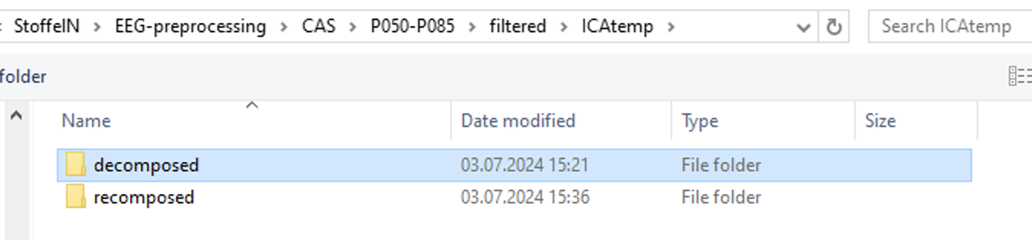

After loading it, go to tools > inspect label/component by map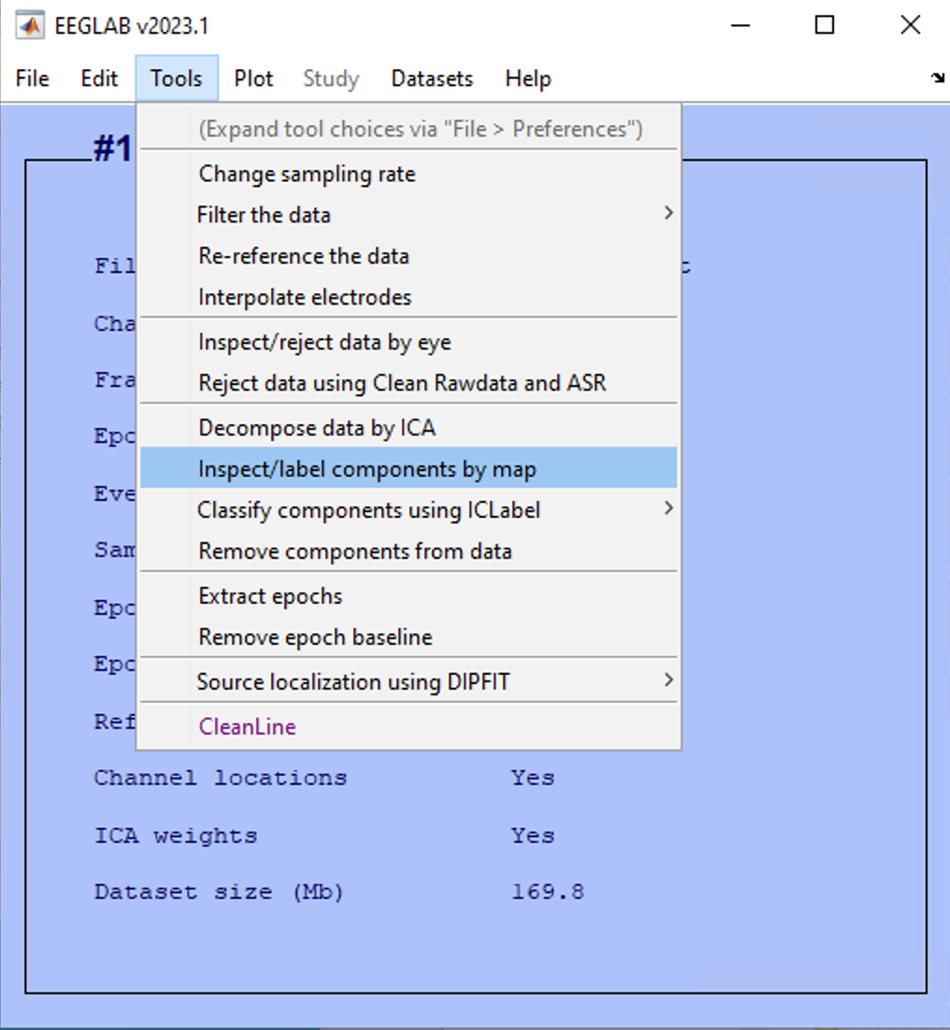, choose the first 20 factors

# How to convert file into another format

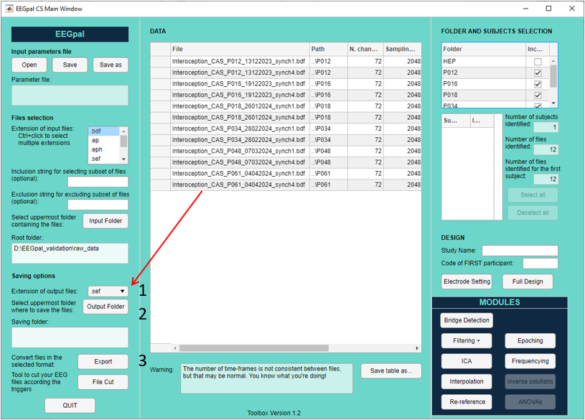

* + 1. Select the output format (.sef, .eph, .ep for Cartool or .set for eeglab)
    2. Choice the folder where the files will be stored
    3. Click on the Export button